The LNM Institute of Information Technology, Jaipur Mid-Semester Examination II, Autumn Semester (2014-15) Control System Engineering (ECE 327)

Time: 1 Hr. M.M.: 40 (Wt.: 20)

- The heat-exchanger temperature control loop is shown in Fig.1
  - Find the range of KA > 0 for which the system is stable.
  - The acceptable value of steady state error is 10C for the step input of 100C. Find the value of KA that meets this specification on static accuracy. [8]

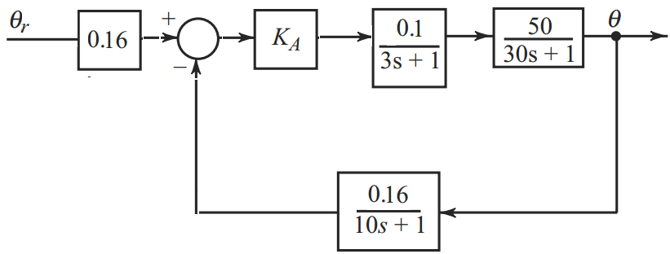
Fig. 1.

- A mechanical vibrating system is shown in Fig. 2 (a). When a Newtons of force is applied to the system, the mass oscillates as shown in Fig. 2(b). Determine the parameters and of the system from the response. [8]

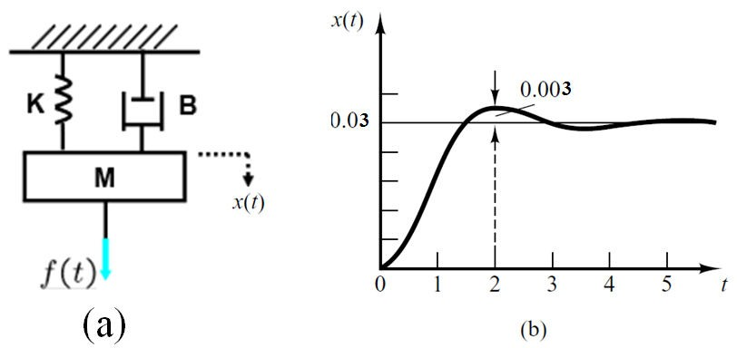
Fig. 2.
- Find the transfer function for the Fig. 3 using the signal flow graph method. [8]

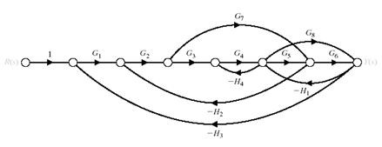
Fig. 3.

- Consider the system, shown in Fig. 4, with reference input and disturbance input .

Fig. 4. 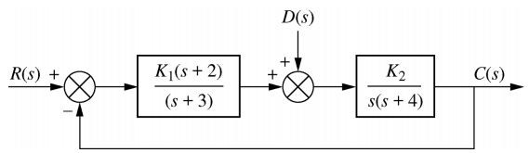
  - Find the transfer function with output and input and the transfer function
with output and input , such that
  - Describe the relationship between the characteristic equation of GR (s) and the characteristic equation of .
  - Find the value of and (both positive constants) to meet the following specifications: i) The steady-state output response due to a unit step disturbance input is 1.2 × 10−5, and ii) the steady- state error due to a unit ramp reference input is 3.0 × 10−3. [8]

5. For a unity feedback system shown in Fig. 5
Fig. 5. 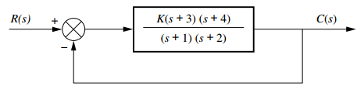
Check whether point s = - 2 + j3 is a closed-loop system pole for some value of gain, K, or not. [8]

***

